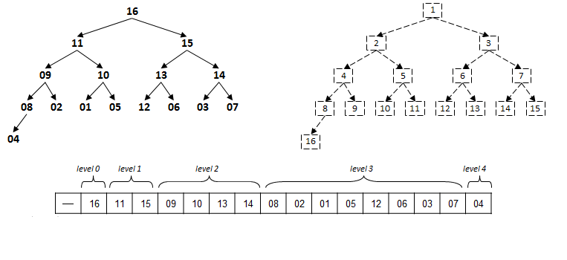 **void** swim(**int** k) {

**while** (k > 1 && less(k/2, k)) {

exch(k, k/2);

k = k/2;

}

}

**void** sink(**int** k) {

**while** (2*k <= N) {

**int** j = 2*k;

**if** (j < N && less(j, j+1)) j++;

**if** (!less(k, j)) **break**;

exch(k, j);

k = j;

}

}

**boolean** less(**int** i, **int** j) {

**return** pq[i].compareTo(pq[j]) < 0;

}

**void** exch(**int** i, **int** j) {

Key swap = pq[i];

pq[i] = pq[j];

pq[j] = swap;

}

